FINAL WEEK: END-TO-END DATA SCIENCE PROJECT REPORT
Data Acquisition • Cleaning • Exploratory Analysis • Visualization • Hypothesis Testing
Internship: Virtual Data Science with Python Apprentice Intern
Internship period: 04 September 2026 – 09 October 2026
Prepared by: ______________________________
Dataset: Iris Flower Dataset
Tools: Python, Pandas, NumPy, Matplotlib, SciPy, scikit-learn

Executive Summary
This report integrates the main skills practiced during the data science internship: obtaining a dataset, checking data quality, exploring patterns, presenting evidence visually, and testing a hypothesis. The Iris dataset contains 150 flower records from three species, with four numerical measurements. The analysis compares petal length for Iris virginica and Iris versicolor. The mean is 5.56 cm for virginica and 4.26 cm for versicolor, a difference of 1.30 cm. A one-sided Welch independent-samples t-test gives t=12.60, p=3.48e-22; this is strong evidence that virginica has a greater mean petal length in this dataset. Recommendations include using a documented data-quality checklist, selecting visuals that suit the audience, reporting effect sizes and confidence intervals alongside p-values, and validating results on representative data before operational decisions.

1. Introduction and Objectives
Data science supports decisions by turning raw observations into validated evidence. This project combines data preparation, exploratory data analysis (EDA), visualization, statistical testing, and recommendations in a reproducible workflow. The Iris dataset is an educational public benchmark; the workflow can also be adapted to quality monitoring, research, agriculture, or customer/product analysis when relevant data are available.
- Load and inspect a documented dataset.
- Check missing values, duplicate records, data types, and measurement consistency.
- Use descriptive statistics and visualizations to identify patterns.
- Define a testable hypothesis and use an appropriate statistical test.
- Interpret the findings and propose practical, cautious recommendations.

2. Dataset and Methodology
The dataset has 150 observations, 50 per species (setosa, versicolor, virginica), and four numeric measurements: sepal length, sepal width, petal length, and petal width, all in centimetres. It is loaded through scikit-learn, making the analysis easy to reproduce. The working table contains 149 rows after exact duplicate removal. The dataset has no missing values in its measurement fields; therefore, no imputation was required.

2.1 Data preparation
from sklearn.datasets import load_iris
import pandas as pd
iris = load_iris(as_frame=True)
df = iris.frame.copy()
df["species"] = df["target"].map(dict(enumerate(iris.target_names)))
df = df.drop(columns="target").drop_duplicates()
print(df.shape)
print(df.isna().sum())
print(df.dtypes)
The checks inspect the row/column count, missing values, and data types. Any future cleaning changes should be documented with the reason for each change.

2.2 Exploratory analysis
Group summaries show that average petal length differs across species:
- Setosa: 1.46 cm mean petal length
- Versicolor: 4.26 cm mean petal length
- Virginica: 5.56 cm mean petal length
Comparing group means and distributions helps identify a question for formal testing. Visualization is used to show both the difference and the remaining overlap between individual measurements.

3. Visual Analysis
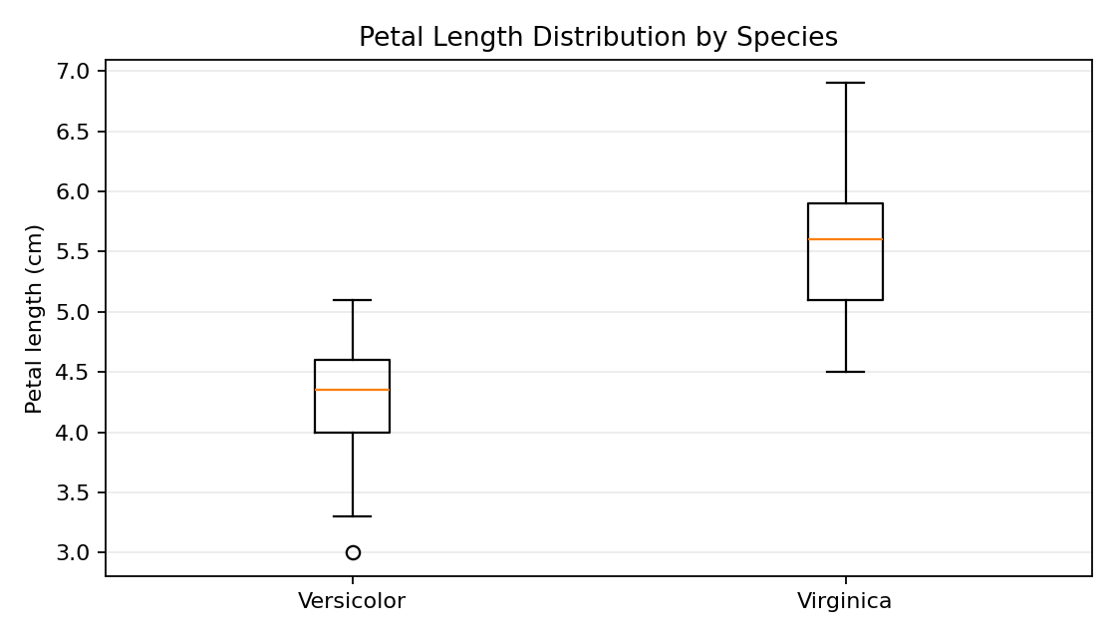
Figure 1. Box plot of petal length by species.
The box plot compares medians, interquartile ranges, and spread. Virginica values are generally higher than versicolor values. Any overlap indicates that petal length alone should not be treated as a perfect identification rule.
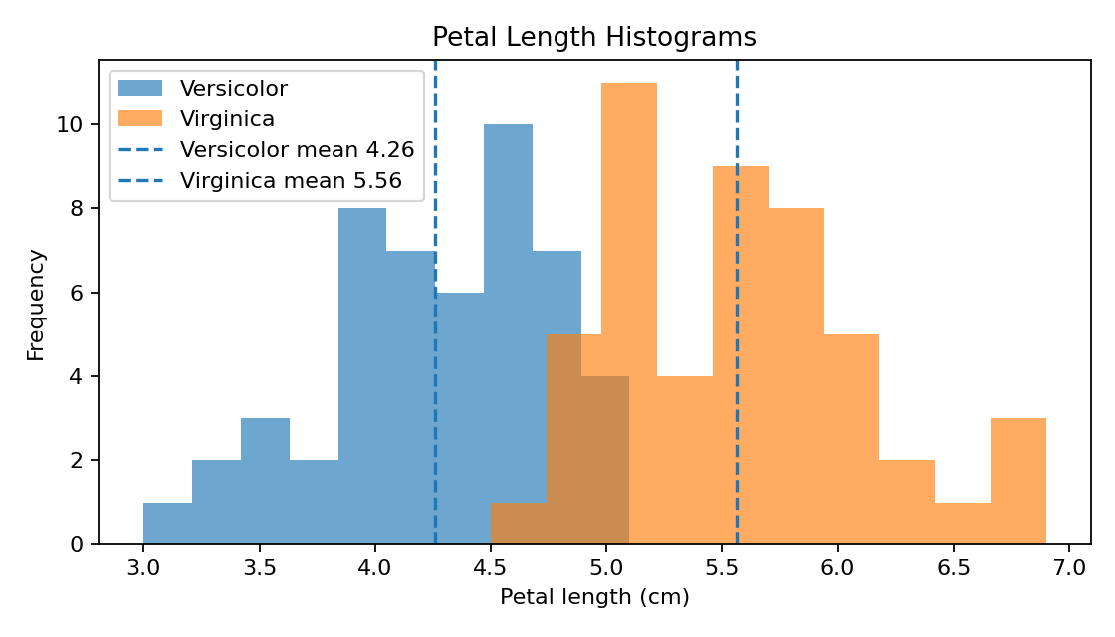
Figure 2. Histograms of versicolor and virginica petal length.
The distributions and dashed mean lines make the average difference visible. Overlap remains, so individual flowers cannot be classified with certainty from this measurement alone.
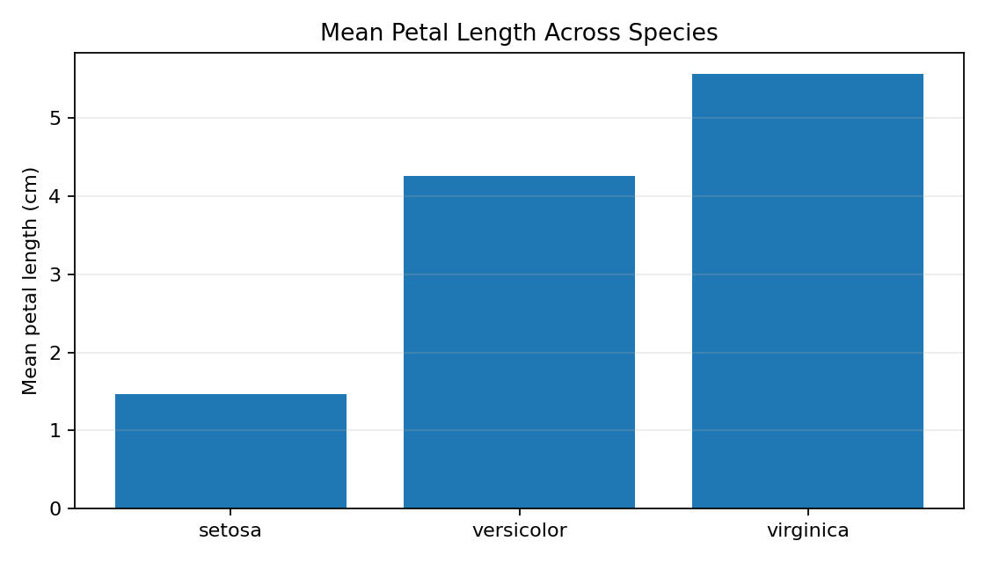
Figure 3. Mean petal length across all three species.
The mean chart gives stakeholders a quick comparison: setosa has the smallest average, versicolor is intermediate, and virginica has the largest average in this dataset.

4. Hypothesis Testing
Research question: Is the population mean petal length of Iris virginica greater than that of Iris versicolor?
Null hypothesis (H₀): Virginica's mean petal length is not greater than versicolor's.
Alternative hypothesis (H₁): Virginica's mean petal length is greater than versicolor's.
Significance level: α = 0.05. Test: one-sided Welch independent-samples t-test, which does not assume equal population variances.
Versicolor: n=50, mean=4.260 cm, SD=0.470. Virginica: n=49, mean=5.561 cm, SD=0.554. Mean difference (virginica − versicolor)=1.301 cm; t=12.595; one-sided p-value=3.48e-22. The approximate two-sided 95% confidence interval for the mean difference is [1.096, 1.506] cm.
from scipy import stats
versicolor = df.loc[df["species"] == "versicolor", "petal length (cm)"]
virginica = df.loc[df["species"] == "virginica", "petal length (cm)"]
result = stats.ttest_ind(
virginica, versicolor,
equal_var=False, alternative="greater"
)
print(result.statistic, result.pvalue)
Interpretation: Since p is below 0.05, reject H₀. Under the test assumptions, the data provide strong evidence that virginica has a greater mean petal length than versicolor. A p-value is not the probability that the null hypothesis is true; it measures how unusual a result at least this extreme would be if the null model were correct. The confidence interval estimates plausible values for the population mean difference. Statistical significance does not by itself establish causation or business importance.

5. Key Findings
- The dataset contains 149 records and three species with balanced groups.
- Mean petal length rises from setosa (1.46 cm) to versicolor (4.26 cm) to virginica (5.56 cm).
- Virginica's mean is 1.30 cm greater than versicolor's in this sample.
- The box plot, histograms, and mean chart communicate the pattern from complementary perspectives.
- The test supports the directional hypothesis for this dataset, but individual measurements overlap.

6. Strategic Recommendations and Potential Impact
Adopt a data-quality checklist. Check missingness, duplicates, ranges, units, and data types before analysis. This improves reliability and reduces avoidable errors.
Match the visualization to the decision. Use box plots for spread, histograms for distributions, and clear mean charts for executive summaries. Include titles, units, legends, and short captions.
Report effect size and uncertainty. Present group averages, mean difference, confidence interval, and p-value together so stakeholders can assess both evidence and practical relevance.
Validate before operational use. For a real business or research setting, collect representative data across relevant sites and times, then validate conclusions on new observations.
Make analysis reproducible. Store scripts, plots, data provenance, software versions, and assumptions in a version-controlled project so others can reproduce the results.
Potential impact: This workflow can support evidence-based comparison, quality monitoring, and research communication. For example, a business could adapt the same steps to compare product measurements or process outcomes. The Iris result itself should not be used to make a commercial decision; the business dataset and decision context must be validated first.

7. Limitations and Future Improvements
- Iris is a small educational benchmark and does not represent every flower population or a direct business environment.
- The analysis focuses on two species and one measurement; other features or multivariable methods may add useful information.
- The t-test assumes independent observations and an appropriate sampling process; dependent or strongly biased samples require a different design.
- A significant result does not prove causation and does not guarantee practical value.
- Future work could collect larger field data, check assumptions using diagnostic plots, compare robust/non-parametric tests, and evaluate classification models on held-out data.

8. Conclusion
This end-to-end project demonstrates how Python can turn raw observations into understandable evidence. After data checks and exploratory analysis, three visualizations showed a consistent difference in petal length between species. Welch's t-test provided strong evidence that Iris virginica has a greater mean petal length than Iris versicolor in this dataset. The key lesson is to combine careful preparation, clear storytelling, appropriate statistical tests, and transparent limitations before recommending action.

Appendix: End-to-End Workflow and Code Notes
# Load -> inspect -> clean -> summarize -> visualize -> test -> recommend
# 1. Document the source and data dictionary.
# 2. Check missing values, duplicates, ranges, and data types.
# 3. Explore distributions and group summaries.
# 4. Create charts with titles, units, and descriptive captions.
# 5. State H0, H1, and alpha before running the test.
# 6. Report the test statistic, p-value, confidence interval, and limitations.
# 7. Translate findings into actionable but appropriately cautious recommendations.

References
- Fisher, R. A. (1936). The use of multiple measurements in taxonomic problems. Annals of Eugenics, 7(2), 179–188.
- scikit-learn, The Iris Dataset: https://scikit-learn.org/stable/auto_examples/datasets/plot_iris_dataset.html
- SciPy, ttest_ind documentation: https://docs.scipy.org/doc/scipy/reference/generated/scipy.stats.ttest_ind.html
- Pandas documentation: https://pandas.pydata.org/docs/
- Matplotlib documentation: https://matplotlib.org/stable/

